AE 4342 – Lab 9

# Power Budgets and EPS

1. , where RE=6,371 km, G=6.67408 × 10-11 m3 kg-1 s-2, h = 600 km, ME=5.972 × 10²⁴ kg, which yields a period of 1.609hr or 1hr 36min 32s. As such it will be in eclipse for 0.306hr or 18min 20s every orbit.

As $\tilde{P_{SA}}={\left(1-ξ\right)}^{τ}\left(cos\left(θ\right)\right)η_{array}S_{A}={\left(1-0.005\right)}^{3}\left(cos\left(20\right)\right)×0.28×1366=354\frac{W}{m^{2}}$

Furthermore, since $\tilde{P_{SA}}=\frac{P_{SA}}{A_{SA}}$, we can derive $A_{SA}=\frac{P_{SA}}{\tilde{P_{SA}}}=\frac{20}{354}=0.0565m^{2}=565cm^{2}$

565/48=11.77 As such, the satellite will need **12 solar cells** to fulfill its power requirement.

b) No, the satellite wouldn’t need deployable solar panels as all of the solar cells could fit on one of the longer sides of the panel, which would be 30x20 cm, to have a total area of 600cm2, more than enough to fit all cells on one side of the CubeSat

2.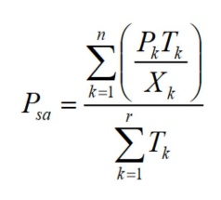, as we know our average power will be 20W whether day or night as 17/0.85=13/0.62=20W. As such $P_{SA}=\frac{20*0.306}{1.609×0.81}=4.695W$. The summation has been removed as the number of periods, the number of sunlit periods and the number of eclipses is the same. We now know that the spacecraft needs 4.695W extra during sunlit hours to be able to power the spacecraft during eclipses. Using the same method as in 1. We find that the area needed is 133cm2, or 2.77 cells. As such, 3 extra cells are needed to supply the satellite from question 1 with power during the complete mission.

However, I just realized this isn’t what is asked for, the number of battery cells is. The full capacity can be calculated as

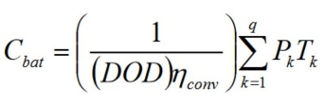, as q=1, the equation becomes $\frac{20*0.306}{0.35*0.87}=20.1Whr$. As one cell has a capacity of 8Whr, 20.1/8=2.5, the spacecraft will need a minimum of 3 cells to supply the satellite from question 1 with power during the complete mission.

b. 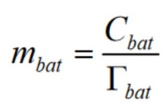= $\frac{3*8}{100}=0.24kg$, a capacity of 24Whr was used as we cannot have half a cell on the spacecraft, we cannot use the capacity of 20.1Whr, and must use the actual capacity as calculated from the number of cells in the battery.

# Communication System

a) 1MB= 8000000 bit, in 27min or 1620s. This gives us a downlink data rate of 4939 bits/s or 5kbps.

b) 1.55 dBi = 1.429

c) 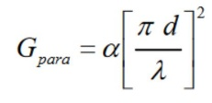, $0.65*{\left[\frac{π2.2}{0.545}\right]}^{2}=104.5=20.2$

d) 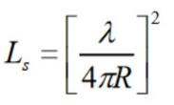, ${\left[\frac{0.545}{4π1000000}\right]}^{2}=1.88*{10}^{-15}=-147.25dBi$

e) $\frac{E_{b}}{N_{0}}=\frac{2*0.38*1.429*0.01*104.5*1.88*{10}^{-15}}{5*1.380649×{10}^{-23}*130}=237751=53dB$

f) Yes, this power to noise ratio is excellent and appropriate to use in this mission. The signal far outweighs the noise and the signal should be clearly received on Earth.